Lab # 01

Objective :

Make a program which recognizes the key strokes as you press different letters.

Example : if you press letter A then it displays the output as
“ Letter A is pressed “

After pressing the 10 letters , it counts the # number of occurrences of the letters.

Lab # 02

Objective:

Make a program which is capable of

Filing
Saving & opening a given text in a file.

Pattern Matching
Searching for a given string in a file

Replacement
Replace the searched string with the given string

Lab # 03

Write a lexical analyzer in any language for the given tokens

Regular Expression | Token | Attribute Value
ws | - | -
if | if | -
then | then | -
else | else | -
id | id | Pointer to table entry
num | num | Pointer to table entry
< | relop | LT
<= | relop | LE
= | relop | EQ
<> | relop | NE
> | relop | GT
>= | relop | GE

Lab # 04
Input Buffering Technique- I

Theory
This lab covers some efficiency issues concerned with the buffering of input. First we’ll look at the two-buffer input scheme that is useful when look-ahead on the input is necessary to identify the tokens. Then in next lab, we’ll explore some useful techniques for speeding up the lexical analyzer, such as the used of sentinels to mark the buffer end.

Buffer Pairs
For many source languages, there are times when the Lexical Analyzer needs to look ahead several characters beyond the lexeme for a pattern before a match can be announced.
A function can be developed to push look-ahead characters back into the input stream. Because a large amount of time can be consumed moving characters, specialized buffering techniques have been developed to reduce the amount of overhead required to process an input character.
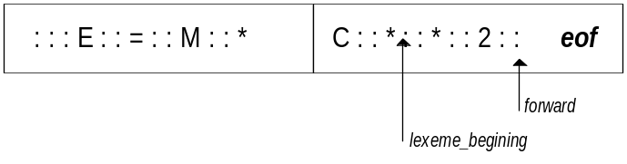In this lab, a buffer divided into two N-Character halves will be used as shown in the figure below; typically N is the number of characters on one disk block e.g. 1024 or 4096.

N characters will be read into each half of the buffer with one system read command, rather than invoking a read command for each input character. If fewer than N characters remain in the input, then a special character eof is read into the buffer after the input characters. eof marks the end of the source file and is different from any input character.
Two pointers to the input buffer are maintained. The string of characters in between the two pointers is the current lexeme. Initially both pointers point to the first character of the next lexeme to be found. One, called the forward pointer, scans ahead until a match for a pattern is found. Once the next lexeme is determined, the forward pointer is set to the character at its right end.
If the forward pointer is about to move past the halfway mark, the right half is filled with N new input characters. If the forward pointer is about to move the past right end of the buffer, the left half is filled with N characters and the forward pointer wraps around to the beginning of buffer.

Code to Advance the Forward Pointer

If forward at end of first half then begin
reload second half;
forward := forward +1;
end
else if forward at end of second half then begin
reload first half;
move forward to beginning of first half;
end
else
forward := forward + 1;

This buffering technique works quiet well most of the time, but with it the amount of look-ahead is limited, and this limited look-ahead may make it impossible to recognize tokens in situations where the distance that the forward pointer must travel is more than the length of buffer.
Lab # 05
Input Buffering Technique- II

Theory
In this lab, we’ll explore a useful technique for speeding up the lexical analyzer, i.e. the use of sentinels.

Sentinels
While using the technique of buffer pairs, we must check each time we move the forward pointer that we have not moved off one half of the buffer; if we do, then we must reload the other half. That is, our code for advancing the forward pointer performs tests as shown in the coding of previous lab.
Except at the ends of the buffer halves, previous code requires two tests for each advancement of the forward pointer. These two tests can be reduce to one if we extend each buffer half to hold a sentinel character at the end. The sentinel is a special character that cannot be part of the source program. A natural choice is eof. The figure below shows the same buffer arrangement as in the previous lab but with sentinels added.
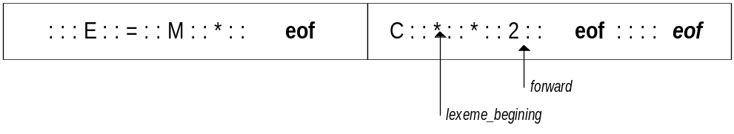

With the above arrangement, we can use the code below to advance the forward pointer (and test for the end of the source file).

Look-ahead Code with Sentinels

forward := forward + 1;
if forward = eof then begin
if forward at end of first half then begin
reload second half;
forward := forward + 1;
end
else if forward at end of second half then begin
reload first half;
move forward to beginning of first half
end
else /* eof within a buffer signifying end of input */
terminate lexical analysis
end

Most of the time the code performs only one test to see whether forward points to an eof. Only when we reach the end of a buffer half or the end of the file do we perform more tests. Since N input characters are encountered between eof’s, the average number of tests per input character is very close to 1.
We also need to decide how to process the character scanned by the forward pointer; does it mark the end of a token, does it represent progress in finding a particular keyword, or what? One way to structure these tests is to use a case statement, if the implementation language has one. The test

if forward = eof

can then be implemented as one of the different cases.

Lab # 06
To Program a Transition Diagram

Theory

Regular Expression
In Pascal, an identifier is a letter followed by zero or more letters or digits. A regular expression is therefore a notation that allows us to define precisely sets such as this. With this notation, we might define Pascal identifier as
Letter (letter | digit)*
The vertical bar means “or”, the parenthesis are used to group sub-expressions, the star means “zero or more instances of” the parenthesized expression, and the juxtaposition of letter with the remainder with the expression means concatenation.

Transition Diagrams
As an intermediate step in the construction of a lexical analyzer, we first produce a stylized flow chart, called a transition diagram. Transition diagram depicts the actions that take place when a lexical analyzer is called by the parser to get the next token.
A transition diagram can be used to keep the track of information of characters that are seen as the forward pointer scans the input. It is done so by moving from position to position in the diagram as characters are read.
In general, there may be several transition diagrams, each specifying a group of tokens. If failure occurs while we are following one transition diagram, then we retract the forward pointer to where it was in the start-state of the diagram. If failure occurs in all transition diagrams, then a lexical error has been detected and we invoke an error-recovery routine.
Consider the following regular expression
(a | b) (a | b)
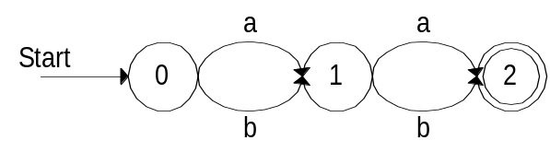The transition diagram for this expression can be constructed as

Implementing a Transition Diagram
A sequence of transition diagrams can be converted into a program to look for the tokens specified by the diagrams. A systematic approach can be adopted to that will work for all transition diagrams and construct programs whose size is proportional to the number of states and edges in the diagram.
Each state gets a segment of code. If there are edges leaving a state then its code reads a character and selects an edge to follow, if possible.

Example Code
Consider the transition diagram given above. Take a string from user and check whether the given input fulfils the regular expression for the same transition diagram or not.
An array of characters can be used as an input buffer. By the definition given in regular expression, two and only characters could be input. First letter could be a or b, which will lead the transition diagram to move to state-1. Similarly second letter can also be a or b, and transition diagram will be terminated by moving towards state-2.

char Buffer[2];
int State = 0, Start = 0;
bool Perfect = False;
take input from user in Buffer;
while ( !Perfect )
{
switch (State)
{
case 0 :
if (Buffer[0] == ‘a’ || Buffer[0] == ‘b’)
State = 1;
else Fail;
break;
case 1 :
if (Buffer[1] == ‘a’ || Buffer[1] == ‘b’)
State = 2;
else Fail;
break;
case 2 :
Perfect = True;
}
}

Practice Problem
Consider the following regular expression:
(a | b) (ba | ab)*
Construct the transition diagram for the above regular expression and implement it in any conventional programming language.
Lab # 07
Recognition of Tokens

Theory
In this lab we’ll address the question of how to recognize the tokens in a given input string. We’ll use the language generated by the following grammar as a running example:
stmt => if expr then stmt |
if expr then stmt else stmt |
ε
expr => term relop term |
term
term => id |
num
where if, then, else, relop, id and num are terminals generating sets of strings given by the following regular definitions:
if => if
then => then
else => else
Similarly consider the regular expression for relop
relop => < | <= | > | >= | = | <>
The transition diagram for the above regular expression is given as follows:

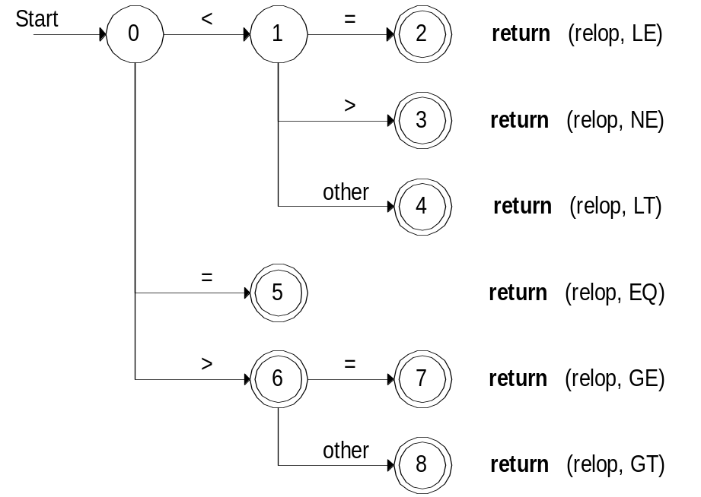

Sample Code for Relop

char C, Buffer[100];
int State = 0, Start = 0;
take input from user in Buffer;
switch (State)
{
case 0 : C = GetNextCharacter();
if ( C == ‘<’ ) State = 1;
else if ( C == ‘=’ ) State = 5;
else if ( C == ‘>’ ) State = 6;
else fail;
break;
case 1 : C = GetNextCharacter();
if ( C == ‘=’ ) return (relop,LE);
else if ( C == ‘>’ ) return (relop,NE);
else return (relop,LT);
break;
case 5 : return (relop,EQ);
break;
case 6 : C = GetNext Character();
if ( C == ‘=’ ) return (relop,GE);
else return (relop,GT);
break;
}

Lab # 08
Recognition of identifiers

Theory
In this lab we’ll address the question of how to recognize the tokens in a given input string. We’ll use the language generated by the following grammar as a running example:
stmt => if expr then stmt |
if expr then stmt else stmt |
ε
expr => term relop term |
term
term => id |
num
where if, then, else, relop, id and num are terminals generating sets of strings given by the following regular definitions:
if => if
then => then
else => else
In this lab, we’ll consider the regular expression for ids
id => letter (letter | digit)*
where letter and digit are given as follows
letter => A | B | … | Z | a | b | … | z
digit => 0 | 1 | 2 | … | 9
Hence the transition diagram for the above regular expression will be
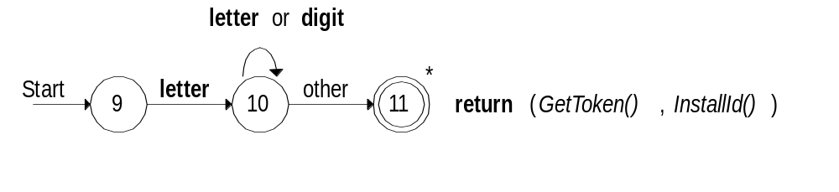

Sample Code for Identifiers

char C, Buffer[100];
int State = 0, Start = 0;
take input from user in Buffer;
switch (State)
{
case 9 : C = GetNextCharacter();
if ( isalph(C) ) State = 10;
else fail;
break;
case 10 : C = GetNextCharacter();
if ( isalph(C) || isdigit(C) )State =10;
else return(GetToken(),InstallId);
break;
}

Main Projects
Project # 1 :
Objective:
Implementation of Lexical Analyzer in any programming language for your context-free grammar .
The steps are:
- Identification of Tokens
- Specification of Tokens in terms of Regular Expressions
- Recognition of Tokens in terms of Transition diagrams
- Coding of Lexical analyzer
( To be submitted before mid-term)

Project # 2 :
( To be submitted after mid-term)
Objective:
Implementation of Syntax Analyzer in any programming language for your grammar .

